EX.NO:08 | LIBRARY MANAGEMENT SYSTEM
DATE:

AIM:
To create a web-based Library Management System using React and Vite that supports a platform where users can add, view, edit, and delete books in a library collection with persistent local storage.

PROCEDURE:
Step 1
Create vite react Using the Commend
npm create vite@latest
Enter The Project Name : Library-Management-System
Select react and javascript
Step 2
Open a folder : Library-Management-System
Replace the code app.jsx
Save the app.jsx file
Step 3
Run The Project
npm run dev
Step 4 : Perform the following operations:
- Add Book → Enter title and author → Click "Add" button
- View Books → All books are displayed in a list
- Edit Book → Click "Edit" button → Modify details → Click "Save"
- Delete Book → Click "Delete" button → Confirm deletion

Specify Folder Name : Library-Management-System in VS Code:
├── app.jsx
import { useState } from 'react'

function App() {
const [books, setBooks] = useState([
{ id: 1, title: 'The Great Gatsby', author: 'F. Scott Fitzgerald' },
{ id: 2, title: '1984', author: 'George Orwell' },
])

const [title, setTitle] = useState('')
const [author, setAuthor] = useState('')
const [editingId, setEditingId] = useState(null)
const [editTitle, setEditTitle] = useState('')
const [editAuthor, setEditAuthor] = useState('')
// Create
const addBook = (e) => {
e.preventDefault()
if (!title.trim() || !author.trim()) return

const newBook = {
id: Date.now(),
title: title.trim(),
author: author.trim()
}
setBooks([...books, newBook])
setTitle('')
setAuthor('')
}
// Delete
const deleteBook = (id) => {
if (window.confirm('Delete this book?')) {
setBooks(books.filter(book => book.id !== id))
}
}
// Start editing
const startEdit = (book) => {
setEditingId(book.id)
setEditTitle(book.title)
setEditAuthor(book.author)
}
// Update
const updateBook = (id) => {
setBooks(books.map(book =>
book.id === id
? { ...book, title: editTitle, author: editAuthor }
: book
))
setEditingId(null)
}
return (
<div style={{ maxWidth: '600px', margin: '0 auto', padding: '20px', fontFamily: 'Arial' }}>
<h1 style={{ textAlign: 'center', color: '#333' }}>📚 Library Manager</h1>

{/* Add Book Form */}
<form onSubmit={addBook} style={{ marginBottom: '30px', display: 'flex', gap: '10px' }}>
<input
type="text"
placeholder="Book Title"
value={title}
onChange={(e) => setTitle(e.target.value)}
style={{ flex: 2, padding: '10px', border: '1px solid #ddd', borderRadius: '5px' }}
/>
<input
type="text"
placeholder="Author"
value={author}
onChange={(e) => setAuthor(e.target.value)}
style={{ flex: 1, padding: '10px', border: '1px solid #ddd', borderRadius: '5px' }}
/>
<button type="submit" style={{ padding: '10px 20px', background: '#28a745', color: 'white', border: 'none', borderRadius: '5px', cursor: 'pointer' }}>
Add
</button>
</form>

{/* Books List */}
<div>
{books.length === 0 ? (
<p style={{ textAlign: 'center', color: '#999' }}>No books yet. Add one above!</p>
) : (
books.map(book => (
<div key={book.id} style={{
background: '#f9f9f9',
padding: '15px',
marginBottom: '10px',
borderRadius: '5px',
display: 'flex',
justifyContent: 'space-between',
alignItems: 'center'
}}>
{editingId === book.id ? (
// Edit Mode
<div style={{ flex: 1, display: 'flex', gap: '10px' }}>
<input
value={editTitle}
onChange={(e) => setEditTitle(e.target.value)}
style={{ flex: 2, padding: '8px', border: '1px solid #ddd', borderRadius: '4px' }}
/>
<input
value={editAuthor}
onChange={(e) => setEditAuthor(e.target.value)}
style={{ flex: 1, padding: '8px', border: '1px solid #ddd', borderRadius: '4px' }}
/>
<button onClick={() => updateBook(book.id)} style={{ padding: '8px 15px', background: '#007bff', color: 'white', border: 'none', borderRadius: '4px', cursor: 'pointer' }}>
Save
</button>
<button onClick={() => setEditingId(null)} style={{ padding: '8px 15px', background: '#6c757d', color: 'white', border: 'none', borderRadius: '4px', cursor: 'pointer' }}>
Cancel
</button>
</div>
) : (
// View Mode
<>
<div>
<strong>{book.title}</strong>
<span style={{ color: '#666', marginLeft: '10px' }}>by {book.author}</span>
</div>
<div style={{ display: 'flex', gap: '8px' }}>
<button onClick={() => startEdit(book)} style={{ padding: '5px 12px', background: '#ffc107', color: '#333', border: 'none', borderRadius: '4px', cursor: 'pointer' }}>
Edit
</button>
<button onClick={() => deleteBook(book.id)} style={{ padding: '5px 12px', background: '#dc3545', color: 'white', border: 'none', borderRadius: '4px', cursor: 'pointer' }}>
Delete
</button>
</div>
</>
)}
</div>
))
)}
</div>
{/* Stats */}
<div style={{ marginTop: '20px', padding: '10px', background: '#e9ecef', borderRadius: '5px', textAlign: 'center' }}>
Total Books: {books.length}
</div>
</div>
)
}
export default App

OUTPUT :

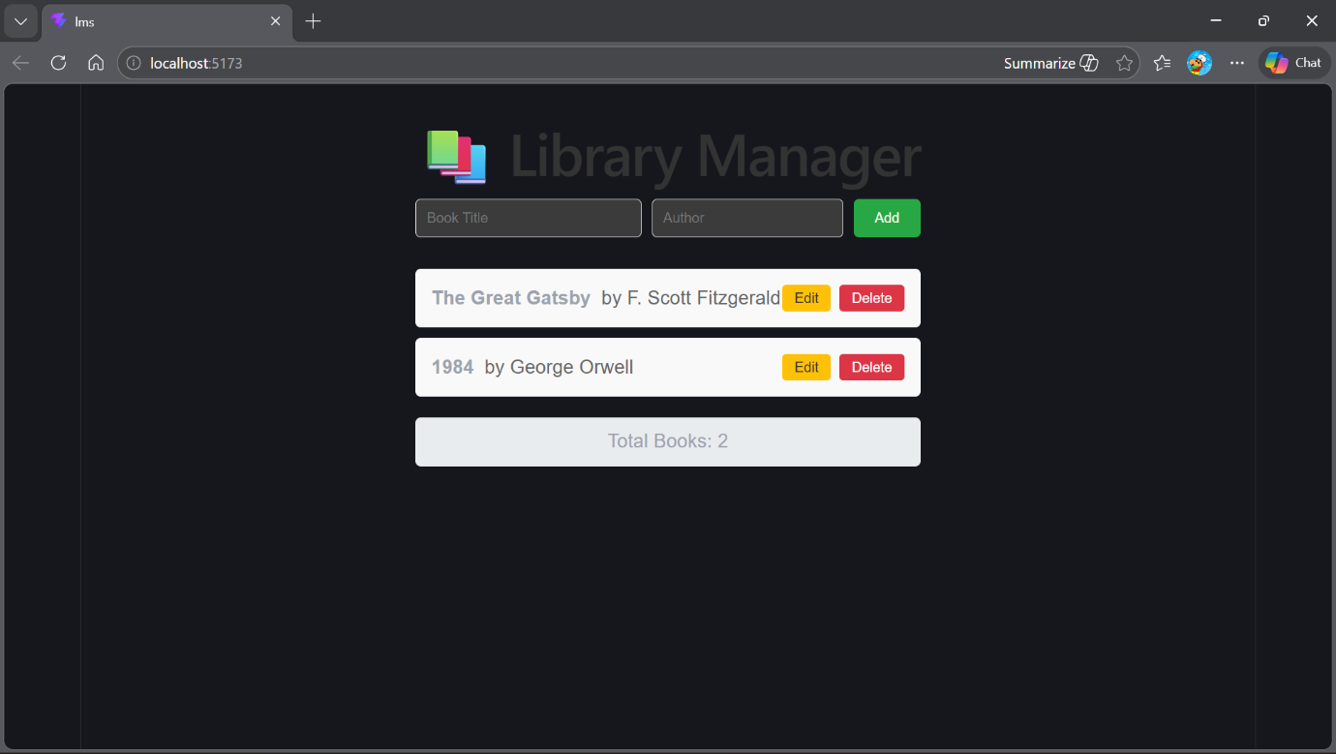

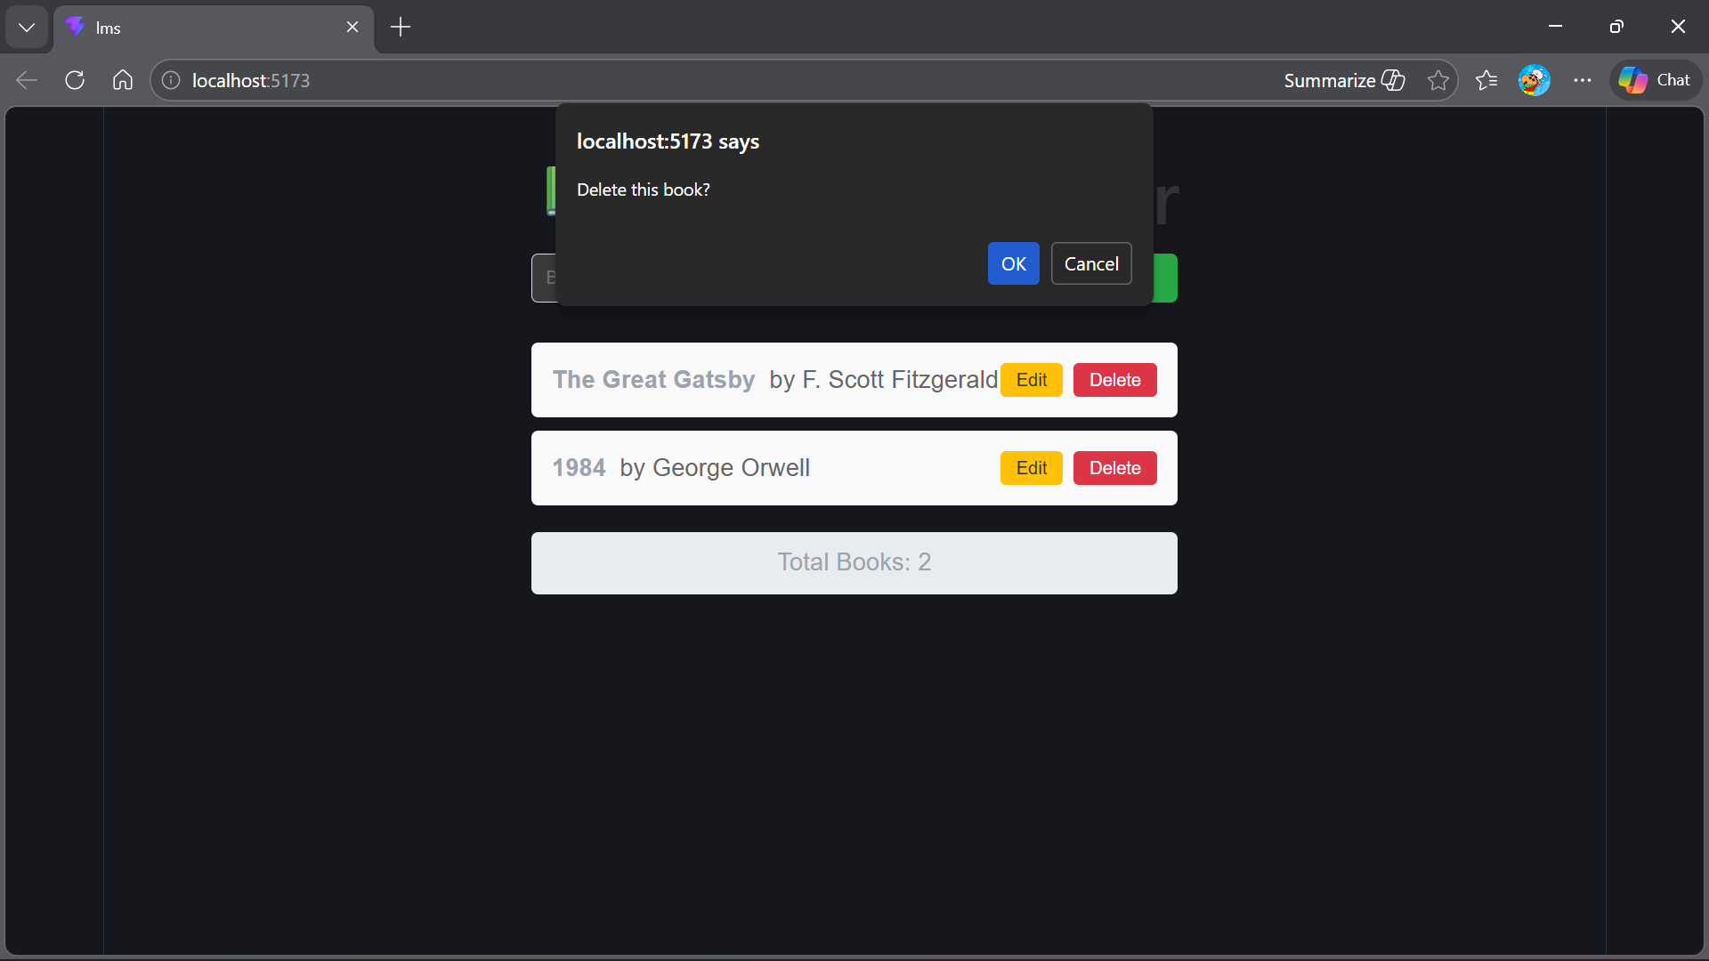

RESULT :
Thus, the Library Management System using React and Vite was designed and executed successfully. The system allows users to: All CRUD (Create, Read, Update, Delete) operations

